オバマ大統領のクリントン支持表明

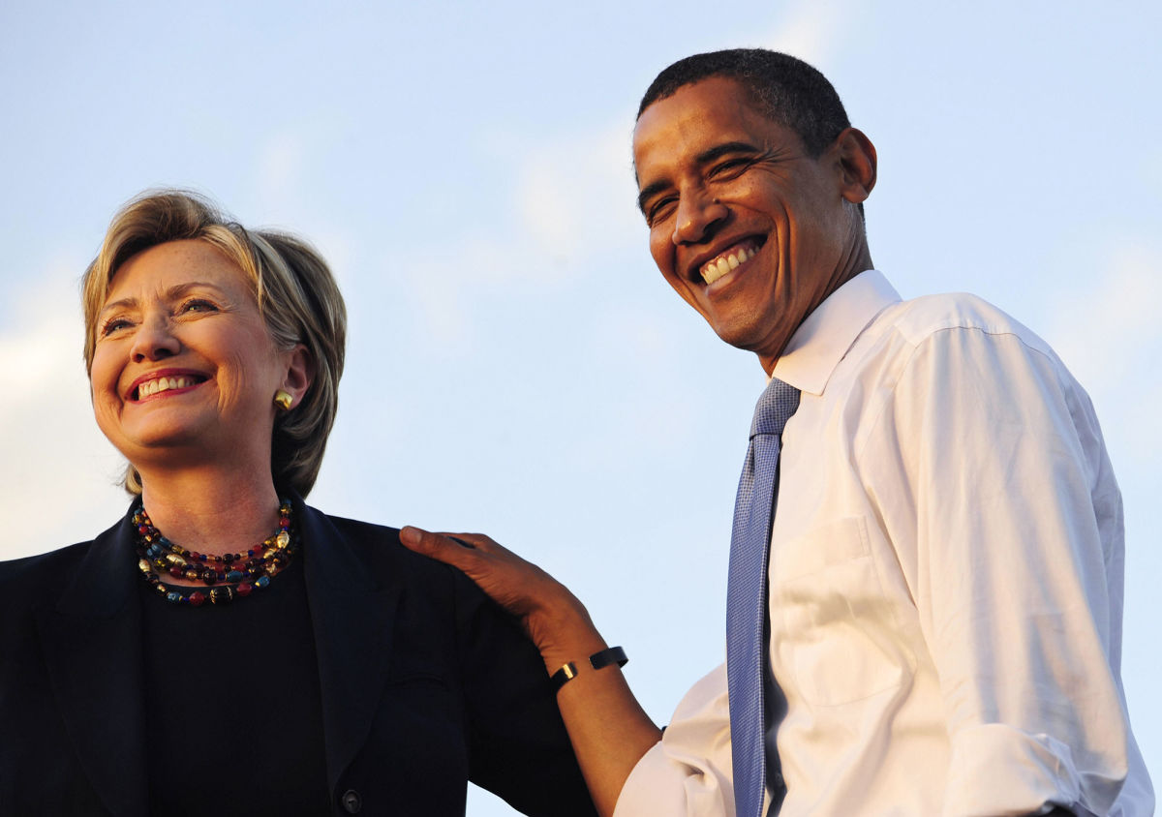

President Obama’s Speech on Endorsement of Hillary Clinton

June 9, 2016 : Released on You Tube

For more than a year now, across thousands of miles, and all 50 states, tens of millions of Americans have made their voice heard. Today, I just want to add mine. I want congratulate Hillary Clinton on making history as the presumptive Democratic nominee for president of the United States.

Look, I know how hard this job can be. That’s why I know Hilary will be so good at it. In fact, I don’t think there’s ever been someone so qualified to hold this office. She’s got the courage, the compassion and the heart to get the job done. And I say that as somebody who had to debate her more than 20 times.

Even after our own hard-fought campaign, in a testament to her character, she agreed to serve our country as secretary of state. From the decision we made in the Situation Room to get Bin Laden, to our pursuit of diplomacy in capitals around the world, I have seen her judgment, I’ve seen her toughness, I’ve seen her commitment to give every American a fair shot at opportunity, no matter how tough the fight was. That’s what has always driven her, and it still does.

So I want those of you who’ve been with me from the beginning of this incredible journey to be the first to know that I’m with her. I am fired up and I cannot wait for Hillary. I also want to thank everybody who turned out to vote and who worked so hard for our candidate. This has been a hard-fought race. I know some say these primaries have somehow left Democratic Party more divided. Well, they said that eight years ago as well.

But just like eight years ago, there are millions of Americans, not just Democrats who’ve cast their ballots for the very first time. And a lot of that is thanks to Senator Bernie Sanders, who has run an incredible campaign. I had a great meeting with him this week, and I thanked him for shining a spotlight on issue like economic inequality and the outsized influence of money in our politics and bringing young people into the process. Embracing that message is going to help us win in November, but more importantly, it’ll make the Democratic Party stronger, and it will make American stronger. Secretary Clinton and Senator Sanders may have been rivals during this primary, but they’re both patriots who love this country and they share a vision for the American that we all believe in.

An America that’s hopeful. An America that’s big-hearted. An America that’s is strong and fair, and give every child the same chance that we had. Those are the values that united us as Democrats. Those are the values that make America great. Those are the values that are going to be tested in this election. And if we all come together in common effort, I am convinced we won’t just win in November, we’ll build on the progress that we’ve made and we will win a brighter future for this country that we love.

